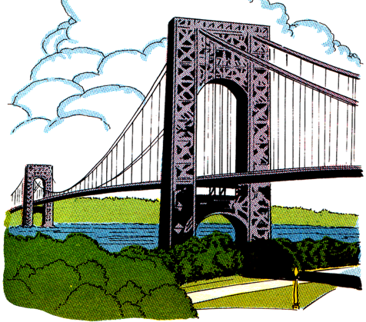
UK Bridges and £1 coins

W.A.L.T create a fact file
Look at the bridges on the 2004–2007 £1 coins. Each one of these £1 coins has an image of a bridge from a country within the UK.

- 2004 £1 coin: Forth Bridge, Queensferry, Scotland
- 2005 £1 coin: Menai Bridge, Anglesey, Wales
- 2006 £1 coin: MacNeill’s Egyptian Arch, Newry, Northern Ireland
- 2007 £1 coin: Gateshead Millennium Bridge, Newcastle Upon Tyne, England.

Task: Create a fact-file about one of the four bridges.

Do some research on each of the bridges. Then choose one to creat a fact file about. Think about the information that will be included in the fact-file. For example:
- When it was built
- Length
- Height
- Materials used to build it and/or who uses it.

Send your completed fact files to Mrs McNally & Mrs Kearney by email or through SeeSaw.

