Home Learning Activities
Week 8: W/B 18th May 2020
Literacy | Numeracy | World Around Us
- Spelling activity:  Practise your spellings using the spelling challenges.  Activities on website  - Grammar:  WALT: understand and use adverbial phrases/ adverbs.  Warm up: What is a verb? What is an adverb?  Can you act out a sentence containing a verb and adverb (eg. Shiver loudly, creep slowly)  New learning: adverbial phrase.  Review and discuss PowerPoint.  Activities sent via Seesaw  - Writing:  Watch & listen to story:  https://www.literacyshed.com/uglysharkling.html  Discuss features of persuasive writing and previous persuasive writing/debating.  Task: using template children:  1) choose an animal best friend and  2) write a PERSUASIVE piece of writing explaining what qualities it would have and why it would make such a good friend.  Title: My Animal Best Friend  Introduction: My animal friend would be a ______called _______.  Argument 1: My animal _____________________ would be a great friend because...  Activities sent via Seesaw  - Reading  -Continue with 20 mins reading each day:  - AR Books  - Oxford E-books  - Collins Big Tree  - MyON  - Record reading in H/W diary/AR record.  -Complete AR tests online  -Listen to stories online | Mental Maths  Label activities daily- sheet has been sent home in poly pocket. One mental maths focus per week.  - WALT: understand decimal numbers (hundredths).  https://www.bbc.co.uk/bitesize/topics/zsjqtfr/articles/zsbd7p3  Talk about the importance of place value and how values become smaller to the right of the decimal point & vice versa. Model this (e.g. 123.45, hundreds, tens, units, decimal point, tenths, hundredths)  Activities sent via Seesaw  - WALT: solve problems.  Problem Solving Type: Exploring patterns  Activities sent via Seesaw/website  - WALT: be able to find the area of a triangle.  https://www.bbc.co.uk/bitesize/topics/zjbg87h/articles/zsqxfcw  How do we find the area of a triangle? What would the formula be?  PowerPoint Presentation: Calculating area of Triangle  Activities sent via Seesaw/website  - WALT: be able to change between units of measure (mm/cm/m).  -What unit of measure would you use to measure length?  -How do we change from km to m, m to cm and vice versa?  -How do we measure very small objects? Builders need to be very precise, 1cm out can be an issue; how do they ensure their measurements are accurate?  -Reinforce how to change between mm and cm.  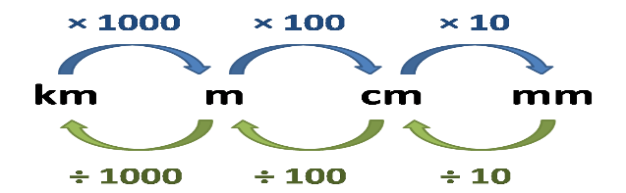  Activities sent via Seesaw/website  Times Tables Rock Stars: complete 5 studio sessions + 1 soundcheck each week.  CLASS BATTLE on Friday from 12-1pm!  Numbots: available to play. | Farm to Fork  Growing Apples: ‘pollination management’  Read and discuss pages 13-16, resources B & D and photographs.  Activity: using Resource C, children will create a design for their own orchard, making sure that their design would work, and the trees would all be pollinated.  Photos and activities sent via Seesaw  Science  Challenges sent via Seesaw during the week.
Other
P.E.:
Go Noodle: online resource for brain breaks
Joe Wicks morning workout on YouTube.

Art:
Use apples (or another food) to create a print artwork. View some ideas via this link or by researching
https://www.pinterest.co.uk/pin/162059286568411700/?autologin=true
Please send me your creations via Seesaw!

R.E.:
Login www.growinlove.ie website:
Primary 6- Theme 9: The Pilgrim Church
Lesson 1: Pilgrimage at Home and Abroad.
Listen to songs. Follow pages 76-77 in E-Book.
Activity: research and write down 6 facts about Croagh Patrick. You may find this website useful:
http://www.croagh-patrick.com/

Homework:
Literacy homework book Day 109-112
MA S3 T4 PA,B & C
Mental Maths label
Spelling activities
Reading

