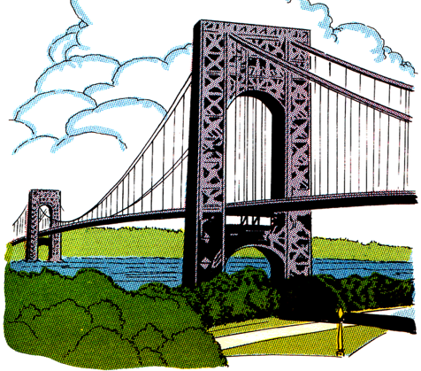
UK Bridges and £1 coins

W.A.L.T present information on a famous bridge.
Look at the bridges on the 2004–2007 £1 coins (use the internet if you haven’t got any at home) Each one of these £1 coins has an image of a bridge from a country within the UK.
- 2004 £1 coin: Forth Bridge, Queensferry, Scotland
- 2005 £1 coin: Menai Bridge, Anglesey, Wales
- 2006 £1 coin: MacNeill’s Egyptian Arch, Newry, Northern Ireland
- 2007 £1 coin: Gateshead Millennium Bridge, Newcastle Upon Tyne, England.

Task: Create a fact-file or information page about one of the four bridges.
Do some research on each of the bridges. Then choose one to create a fact file about. Think about the information that will be included in the fact-file. For example:
- When it was built
- Length
- Height
- Materials used to build it and/or who uses it.

As always – you can choose to present this however you like! Remember to include pictures and/or diagrams of your chosen bridge.

Send your completed fact files to Mrs McNally & Mrs Kearney by email or SeeSaw.

