Literacy  Reading: 2 Online books set on SeeSaw- Try1 A.R. quiz a week! Keep building your word count!  Monday: Spelling pattern – Check SeeSaw. Complete spelling activity/spelling sentences. Choose an outdoors spelling challenge card to complete!  Tuesday: Comprehension- next page in booklets. Remember full sentences & re-read text!  Wednesday: Grammar- Punctuation Revision- Always remember to read over your work! Check SeeSaw for tasks.  Thursday: Continue with ‘Home Learning Time Capsule’ (on SeeSaw & school website). You can always send us pictures of what you create!  Friday: Complete spelling/number facts Friday test! Ask an adult or sibling to test you! | Numeracy  Monday & Tuesday: Revision of 3-digit OR 2-digit number place value Check SeeSaw for tasks- You can complete on a printed sheet or write your answers on a sheet!  Wednesday-Thursday: ‘Telling the Time’- Working on digital & analogue clock times for o’clock, half past, quarter to/past & 5-minute intervals- Check SeeSaw/website for activity sheets.  Friday: Complete spelling/number facts Friday test! Ask an adult or sibling to test you!  Make sure to visit the school website for more teaching resources to help with your understanding! | WAU/Topic – (our final topic is ECO WARRIORS)  This week we will be learning about RECYCLING  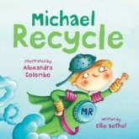  Watch, Listen & Learn: Watch & listen to the story of ‘Michael Recycle’ by following the link on YouTube:  https://www.youtube.com/watch?v=pJweMxEhjlU  Thinking Task: Using your understanding of how to be an ‘eco warrior’ so far, can you think of 5 ways we can take care of the Earth?  Creative Task: Can you create your very own Recycling Superhero? Label your superhero with a catchy name and create an ‘eco warriors’ superpower for your character!
I.C.T.
Education City:
Check and see what games & videos have been set for you by your teacher.
Times Table ROCKSTARS:
Visit the ‘Times Table Rockstars’ website & log in with your details. Keep practising your tables!
Weekly Focus  Spend time doing something you love - outdoor play, baking, games, watching a movie, being creative! Share it with us!  Waste Saving: Check out some of the ‘waste saving’ recipes on our class website page. To be an Eco Warrior, we should always aim to save waste (including food waste). Find ways to use up leftovers!  Homework  - English in Practice (Mon-Thurs).  - Mental Maths (Mon-Wed) | 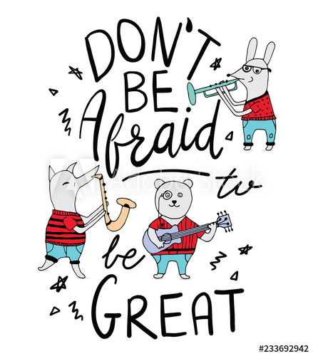 | R.E./ Self Care Activities/P.E  R.E: Grow in Love: Them 9 ‘Creation’.  - Lesson 1: God Created Us – listen to the song, read the poem & play the treasure trial to find things God created.  P.E: Athletics- Can you practise your running, jumping, throwing & catching skills this week?  Self-Care: Can you make a poster using the ‘I Am’ Mind map as a guide? What are YOUR gifts and talents? You can draw/write them in the bubbles or take a photo to show us on SeeSaw!

