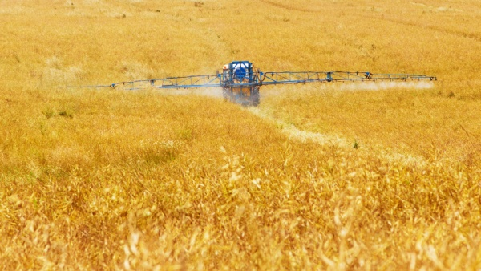

- The spray tank on a sprayer holds 5000 litres. If 100 litres of spray is needed on every hectare of land, how many hectares can be sprayed with one load?

- Every 100 litres of water in the tank needs to be mixed with 4 litres of spray chemical. How much spray chemical is needed when 5000 litres are in the tank?

- Farmer Fred sells his old tractor for £20,500 and he buys a new tractor for £90,000. How much extra money does he need to find?

- Fred sells his old combine for £200,000 and wants to buy a new combine for £400,000.
He does not have enough money all at once so he agrees to pay part of the cost each year for 5 years. How much money does he pay each year?

