Literacy  Reading: Continue to read at home and take AR quizzes  https://ukhosted3.renlearn.co.uk/2235372/default.aspx  Monday: Spelling Activity:  Please refer to See Saw for Group Tasks  Tuesday: Grammar: Identifying the Subject and object in a sentence  Link: https://www.youtube.com/watch?v=tv205iQZR7c  Please refer to See Saw for Group Tasks  Wednesday: Writing: Creative Writing  Group 1 Group 2 Group 3 Group 4  Write a story with the following title:  The Phone Call  Please complete this task in your Literacy Book, Thank You  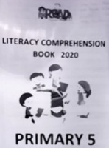  Thursday: Comprehension:  Please complete a comprehension from the ‘Literacy Comprehension Booklet’ – this booklet was sent home.  Friday: Friday Test  Ask an adult or sibling to test you!  Handwriting - Try writing your spelling list in cursive script | Numeracy  Monday: Negative Numbers  Link: https://www.youtube.com/watch?v=vHi5hMJtZpY  Please refer to See Saw for Group Tasks  Tuesday: Venn Diagrams  Link: https://www.youtube.com/watch?v=yTFoprO5fgM  Please refer to See Saw for Group Tasks  Wednesday:  Times Tables Rock Stars or Numbots  Thursday: Carroll Diagrams  Link: https://www.youtube.com/watch?v=C02Bd3-tM9k  Please refer to See Saw for Group Tasks  Friday: Weekly Challenge!  Ask an adult or sibling to test you! | Other Curriculum Areas  Topic: Natural Disasters/ Extreme Earth  Avalanches  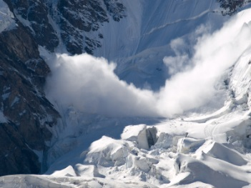  An avalanche is a mass of snow, ice, and rocks falling rapidly down a mountainside.  We would like you to carry out your own research on avalanches and then complete the following activities:  Question Key  The answer is avalanche. List five questions to give that answer  Impact Key  The impact of avalanches. Copy and complete the table  Impact on Humans Impact on the environment  Can you think of any positive impacts?  Homework  Monday Reading Spellings Number facts  EIP day 125 MA S3 Test 8a MA Monday ABC order  Tuesday Reading Spellings Number facts  EIP day 126 MA S3 Test 8b MA Tuesday Rainbow  Wednesday Reading Spellings Number facts  EIP day 127 MA S3 Test 8c MA Wednesday V and C  Thursday Reading Spellings Number facts  EIP day 128 Calculations Practice Test

