Literacy  Reading: Continue to read at home and take AR quizzes  https://ukhosted3.renlearn.co.uk/2235372/default.aspx  Monday: Spelling Activity:  Please refer to See Saw for Group Tasks  Tuesday: Grammar: Revision Homophones  Link: https://www.youtube.com/watch?v=lCE7nSPCVJ4  Please refer to See Saw for Group Tasks  Wednesday: Writing: Creative Writing  Group 1 Group 2 Group 3 Group 4  Write a story with the following title:  The Emergency  Please complete this task in your Literacy Book, Thank You  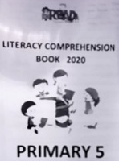  Thursday: Comprehension:  Please complete a comprehension from the ‘Literacy Comprehension Booklet’ – this booklet was sent home.  Friday: Friday Test  Ask an adult or sibling to test you!  Handwriting - Try writing your spelling list in cursive script | Numeracy  Monday: x10 and x100  Link: https://www.youtube.com/watch?v=7Y0zSnhiShc  Please refer to See Saw for Group Tasks  Tuesday: Tree Diagrams  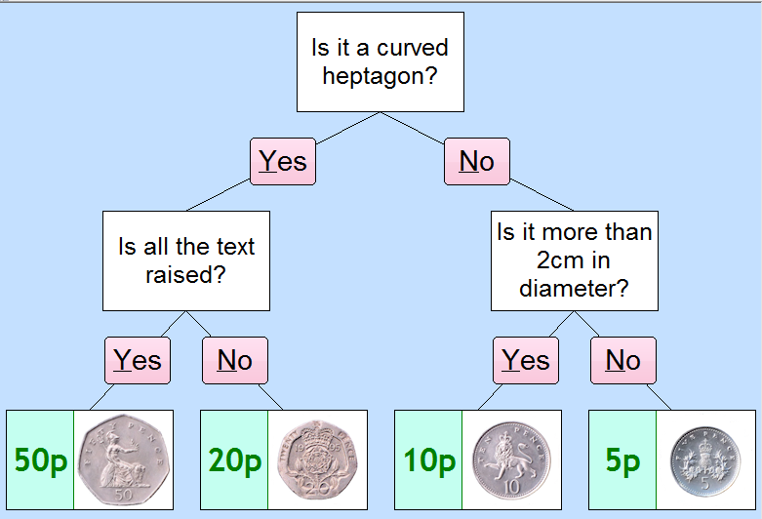  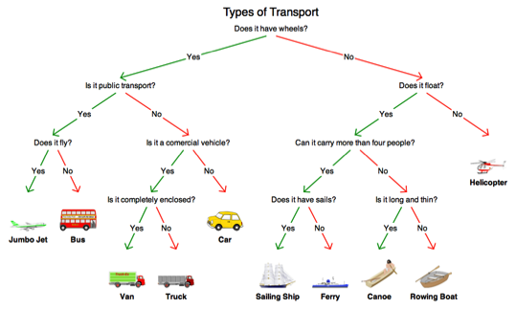  Please refer to See Saw for Group Tasks  Wednesday:  Times Tables Rock Stars or Numbots  Thursday: Pie Charts  Link: https://www.youtube.com/watch?v=Ruc9n6ho3l4  Please refer to See Saw for Group Tasks  Friday: Weekly Challenge!  Ask an adult or sibling to test you! | Other Curriculum Areas  Topic: Natural Disasters/ Extreme Earth  Droughts  A drought is a prolonged period of abnormally low rainfall, leading to a shortage of water.  We would like you to carry out some research and then complete the following activities:  What if?  What if the world’s water supply dried up? List 10 consequences  Cook Up: ‘Antrim’s Amazing Appetizers’  Bush Tucker Menu, Antrim Style – the drought has meant you have to be adventurous with what you can offer people on your menu. Ingredients are limited because of the drought, design your own ‘Antrim’s Amazing Appetizers’  Homework  Monday Reading Spellings Number facts  EIP day 129 MA S3 Test 9a MA Monday ABC order  Tuesday Reading Spellings Number facts  EIP day 130 MA S3 Test 9b MA Tuesday Rainbow  Wednesday Reading Spellings Number facts  EIP day 131 MA S3 Test 9c MA Wednesday V and C  Thursday Reading Spellings Number facts  EIP day 132 Calculations Practice Test

