Literacy  Reading: Continue to read at home and take AR quizzes  https://ukhosted3.renlearn.co.uk/2235372/default.aspx  Tuesday: Grammar: Revising Prefix and Suffix  Links: https://www.youtube.com/watch?v=l170VTskxKA  https://www.youtube.com/watch?v=HUtmHT7DOvI  Please refer to See Saw for Group Tasks  Wednesday: Writing: Creative Writing  Group 1 Group 2 Group 3 Group 4  Write a story with the following title:  The Visitor  Please complete this task in your Literacy Book, Thank You  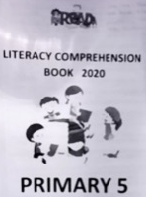  Thursday: Comprehension:  Please complete a comprehension from the ‘Literacy Comprehension Booklet’ – this booklet was sent home.  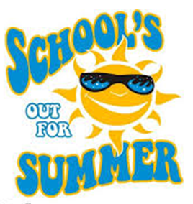  Friday 26th June  Happy Holidays! | Numeracy  Monday: ÷10 and ÷100  Link: https://www.youtube.com/watch?v=PPMnbH2M0io  Please refer to See Saw for Group Tasks  Tuesday: Time: 5-minute Intervals (Analogue to Digital)  Link: https://www.youtube.com/watch?v=N2z9CGzAypc  Please refer to See Saw for Group Tasks  Wednesday:  Times Tables Rock Stars or Numbots  Thursday: Timetables  Link: https://www.youtube.com/watch?v=40BJ0o0VD-0  Please refer to See Saw for Group Tasks  Homework  Monday Reading Spellings Number facts  EIP day 133 MA S3 Test 10a MA Monday ABC order  Tuesday Reading Spellings Number facts  EIP day 134 MA S3 Test 10b MA Tuesday Rainbow  Wednesday Reading Spellings Number facts  EIP day 135 MA S3 Test 10c MA Wednesday V and C  Thursday Reading Spellings Number facts  EIP day 136 Calculations Practice Test | Other Curriculum Areas  Topic: Natural Disasters/ Extreme Earth  Floods  A flood is when water covers land that is usually dry, while flash floods are floods that happen very quickly. Floods can be caused by many different events, including hurricanes, melting snow, and breaking dams. The ground becomes saturated with, or full of, water and the water level has to rise.  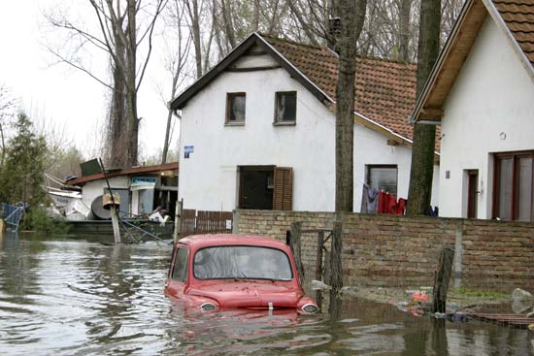  We would like you to research information on floods and then complete the following activities:  Compare and Contrast: Copy and complete the template noting the similarities and differences between droughts and floods  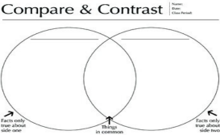  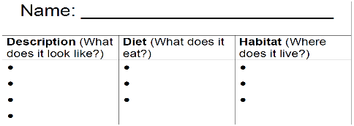  Originality Key: The flood is over, and you have just discovered a new creature that has NEVER been seen before. Draw a picture of it. Give it a name. Describe what it looks like, what it eats and where it lives.

