**Collecting and Representing Data**

During the past few lessons you have looked at ways of collecting and representing data. You will now put all of your knowledge together to complete these questions.

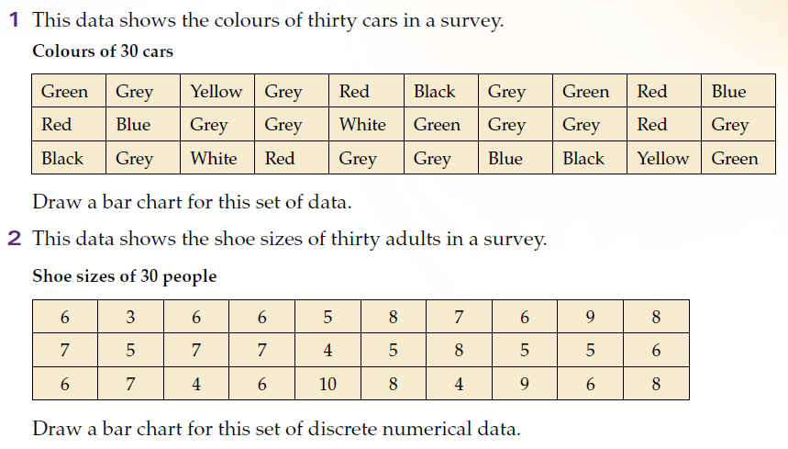**Question 1:** The information shown displays the colour of 30 cars in the school car park. Complete the tally chart below.

|  |  |  |
| --- | --- | --- |
| **Car Colour** | **Tally** | **Frequency (Total)** |
| Green |  |  |
| Grey |  |  |
| Yellow |  |  |
| Red |  |  |
| Black |  |  |
| Blue |  |  |
| White |  |  |

**Question 2:** Using your Frequency table answer these questions.

a) How many cars on the car park are Grey?

b) How many more Red cars than White cars are there?

c) Which is the most popular colour?

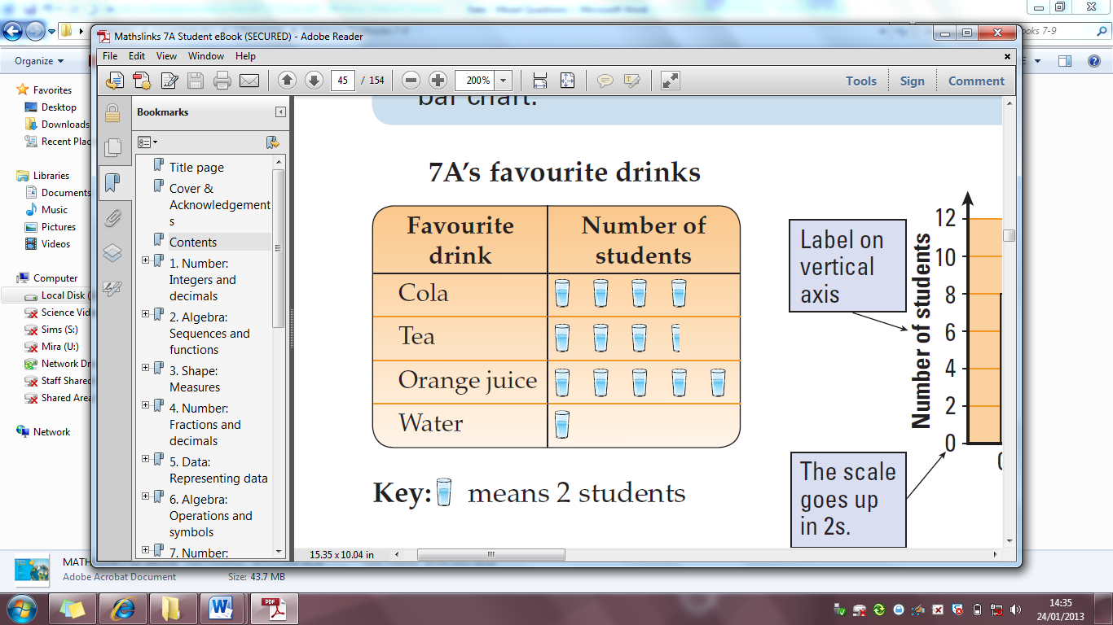

**Question 3:** Using the Pictogram on the right answer the following questions.

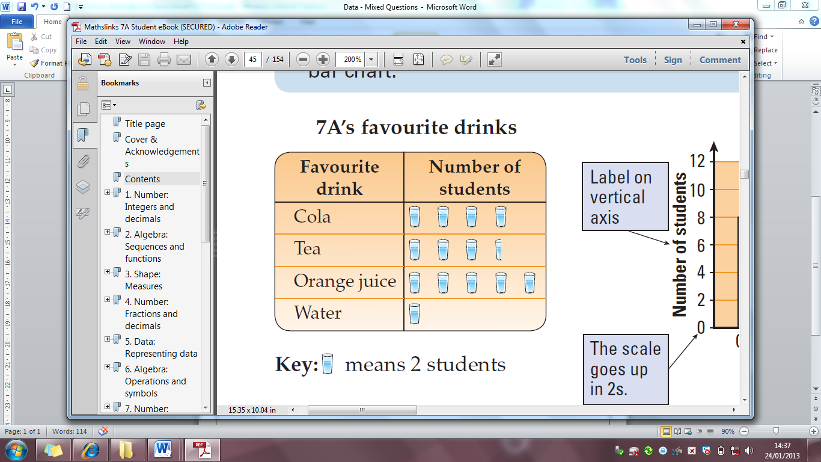

When stands for 2 students:-

a) How many students liked Cola?

b) How many students liked Tea?

c) How many more students liked Orange Juice than water?



If stood for 1 student, explain why this could not be possible.

……………………………………………………………………………………………………………………………………………………………………………………………………………

……………………………………………………………………………………………………………………………………………………………………………………………………………

C:\Program Files\Microsoft Office\MEDIA\CAGCAT10\j0299763.wmf**Question 4:** The number of goals scored by a footballer this season can be represented by a . Using the information below draw a Pictogram to represent the information .

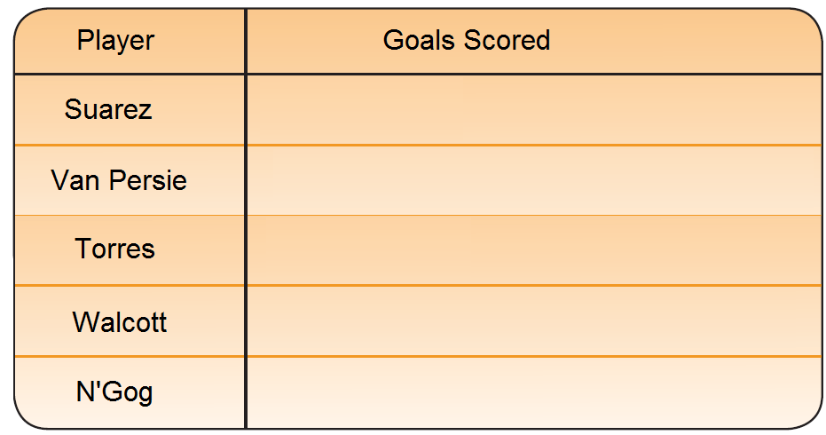

Suarez = 16

Van Persie = 18

Torres = 5

Walcott = 10

N’Gog = 3

Key:  = 2 goals