Minibeast topic activities.
Select an activity and complete in your topic book. You can choose activities in any order.
Alphabet it!  Write the alphabet. Can you think of the name of a minibeast for each letter of the alphabet? | Draw it!  Find a minibeast in your garden. Look at it carefully and draw a picture in your topic book? | Create  Build a minibeast using junk art materials e.g. boxes, plastic bottles cardboard tubes.
Find out!  Choose a minibeast to investigate. What can you find out about your minibeast?  Create a fact file in your topic book. | 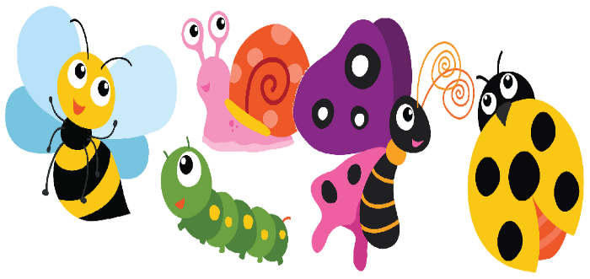 | What if?  If you were like the caterpillar and could change in any creature, what creature would you change into? Explain your reasons?
Compare and Contrast  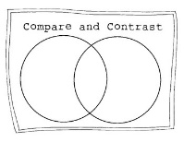  Use a compare and contrast template to think about the similarities and differences between 2 minibeasts. | B.A.R.  B.A.R. a Ladybird  Make it BIGGER  ADD something  REPLACE something  Draw a picture and label the parts | Find out!  Find out about the lifecycle of a caterpillar. Draw, label and describe the stages in your topic book.
Minibeast experiments (Just for fun!)
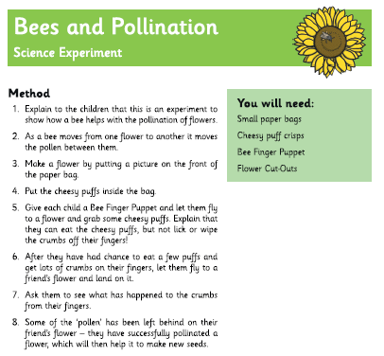
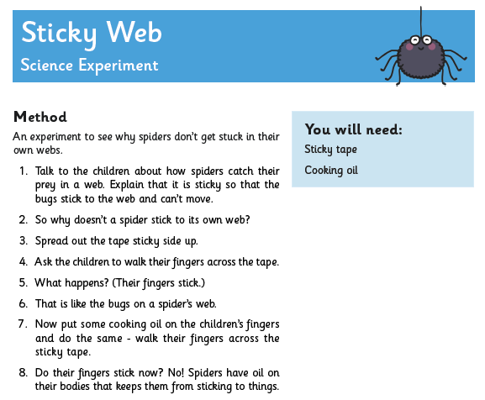

Minibeast experiments (Just for fun!)
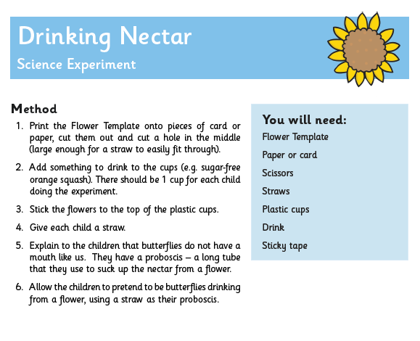

Resource page

