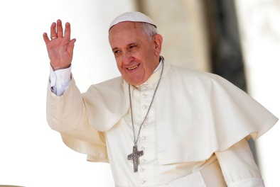
P7 Religion task week beginning 27th April 2020
Pope Francis

This week we are learning about Pope Francis, his childhood, how he became a priest and later a bishop and Pope.
You are going to create a fact-file about him.

- Read the story about Pope Francis from our Grow in Love book (see document on our class website page)

- In your Religion book – write down some information you have found out about him (you might want to use the internet for some extra information!)

- Plan your fact-file. What relevant information should be included? What images could you use to represent his life? How will you lay it out? (There are some nice ones on the internet if you want to check them out for some inspiration!)

- Create your fact-file in your Religion book. Remember to use drawings, neat handwriting and plenty of colour.

- When you have finished , take a photo of your work and send it to Mrs Kearney or Mrs McNally on Seesaw – we would love to see them!

Good luck!

