Literacy  Reading: 2 online eBooks set  on SeeSaw – Take an A.R quiz after!  Monday: Spelling Pattern (check SeeSaw). Spelling activity/sentences. Bubble letter practice.  Tuesday: Complete ‘The Messy Magpie’ comprehension (check See Saw for task as it is not in booklet!)  Wednesday: Grammar focus – Using and recognising ‘prefixes’ OR ‘nouns’ work. Check website for learning information & SeeSaw for task.  Thursday: ‘My Favourite Game’. Write and describe your favourite game. Remember to add an explanation of how to play using clear instructions. Add a picture too!  Friday: RELAX!! | Numeracy  Monday: Revision of multiplication (x3, x4) OR number facts practice. Check SeeSaw for tasks. Visit Times Tables Rockstars to practise quick recall of tables learnt so far.  Tuesday/Wednesday: Continue with TU multiplication by 2, 3 and 4 OR TU addition calculation work. Use your PowerPoint steps & teacher video to help you. Check SeeSaw for calculations work.  Thursday: Complete Spelling & Number facts test! Ask an adult or sibling to test you! .  Friday – RELAX!! | WAU/Topic – (May/June)  We have come to our final WAU topic which is Eco Warriors. We are thinking about ‘Littering’ this week.  Watch and Learn: Read the story ‘The Messy Magpie’ found on our school website, with an adult or sibling.  Creative Task: Please visit school website for information links and PowerPoint.  1. Can you create a ‘mind map’ to show all the different types of ‘waste’ (food, litter, household). Check SeeSaw for an example of this  2. Challenge: ‘Design your own Bin’. Check SeeSaw for challenge.
I.C.T.
SeeSaw Activity – Check your class SeeSaw and try to complete your activity this week. Remember to upload!

Education City -
Check and see what games & videos have been set for you by your teacher. They will help with your Literacy & Numeracy areas this week.
Weekly Focus  Handwriting: This week we are focusing on the one armed robot letters (start at the top, back up and round). Use the pictures below to help you.  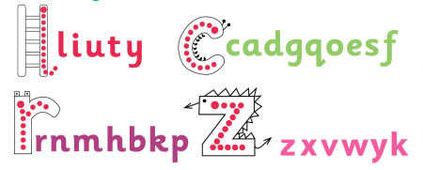  Homework This Week: Continue with English in Practice (Mon-Thurs) and Mental Arithmetic (Mon-Wed).  Remember: Online My Maths Thursday |  | R.E./ P.E  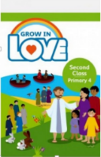  R.E: Visit the ‘Grow in Love’ webpage.  - P4 Theme 8: We Can Live like Jesus asked: Lesson 2- ‘I will send a Helper’. Listen to the videos, songs & activities.  - Join Fr James for his weekly lesson on ‘Parish of Antrim’ Facebook on Friday at 1pm.  P.E: Make an obstacle course in your house or garden. How fast can you complete it?  Self-Care: Can you create a cosy ‘book nook’ area for you to read in? It could be like a den or a comfy area with cushions, blankets and your favourite teddy. Relax, unwind and read a good book!

